# 



TeamViewer

Custom Configurations

Version 1.0

Document Overview

|  |  |  |  |
| --- | --- | --- | --- |
| Title | **TeamViewer Custom Configurations** | Version | **1.0** |
| Project | **Commerce Link** | **Status** | **Approved** |
| Client | **Team Viewer** | **Type** | **Internal/External** |
| Doc # |  | **Doc Date** | **Jan 09, 2018** |
| Author | **Noman Saeed** | **Last Save** | **Jan 09, 2018** |
| Description | This document contains Guide for Mobile Business Assistant Deployment. | | |

***Revision History***

|  |  |  |  |
| --- | --- | --- | --- |
| **Version #** | **Rev Date** | **Author** | **Brief Description** |
| 1.0 | **Jan 09, 2018** | Noman Saeed | Add following FDDs configurations (007, 009, 013, 030) |
| 1.0 | **Jan 10, 2018** | Imran Javed | Add FDD 045 (Service Profile Configuration) |
| 1.0 | **Jan 11, 2018** | Noman Saeed | Add FDD 001 & 012 (Product & Price) |
| 1.0 | **Jan 12, 2018** | Imran Javed | Update FDD 001 & 012 (Product & Price) |
| 1.0 | **Jan 15, 2018** | Noman Saeed | Update Sales order Customization for TeamViewer |
| 1.0 | **Jan 17, 2018** | Usman Younas | Add FDD-086 (Payment Integration) |
| 1.0 | **Feb 05, 2018** | Noman Saeed | Update FDD-007 and FDD-013 for D365 manual fields mapping |
|  |  |  |  |

***Distribution List***

***Approved By***

|  |  |  |
| --- | --- | --- |
| **Name** | **Role** | **Version** |
| Noman Saeed | Technical Lead | 1.0 |
|  |  |  |
|  |  |  |

Table of Contents

Document Overview 2

***Revision History*** 2

***Approved By*** 2

1. FDD-007 Create Contract Order 6

1.1. D365 Configurations: 6

Sales Order Customization Mapping in AX 6

1.2. Channel Database Changes: 9

1.3. CommerceLink Database Changes: 11

1.4. CommerceLink Configurations: 11

1.5. Effected Areas: 11

2. FDD-045 Service Profile Configuration 12

2.1. D365 Configurations: 12

Adding Tables to Data Distribution 13

Add Sub Jobs 13

Generate Queries 14

Add Sub Jobs to 1070 Job 14

2.2. Channel Database Changes: 15

2.3. CommerceLink Database Changes: 15

2.4. CommerceLink Configurations: 15

2.5. Effected Areas: 15

3. FDD-013 Channel Profile Configuration 16

3.1. D365 Configurations: 16

Channel Profile Settings 16

Customer Satisfaction Period Settings 16

Verify Table to Data Distribution 17

Update Sub Jobs 17

3.2. Channel Database Changes: 18

3.3. CommerceLink Database Changes: 18

3.4. CommerceLink Configurations: 18

4.5. Effected Areas: 19

4. FDD-001 and FDD-012 Product Information and Base Price 20

4.1. Cross sell/Up sell Changes: 20

4.1.1. D365 Configurations: 20

Adding Tables to Data Distribution 22

Add Sub Jobs 22

Generate Queries 22

Add Sub Jobs to 1150 Job 23

4.1.2. Channel Database Changes: 23

4.1.3. CommerceLink Database Changes: 23

4.1.4. CommerceLink Configurations: 23

4.1.5. Effected Areas: 23

4.2. Product Custom Fields: 24

4.2.1. D365 Configurations: 24

Adding Tables to Data Distribution 24

Add Sub Jobs 24

Generate Queries 25

Add Sub Jobs to 1040 Job 25

4.2.2. Channel Database Changes: 25

4.2.3. CommerceLink Database Changes: 25

4.2.4. CommerceLink Configurations: 25

4.2.5. Effected Areas: 25

5. FDD-006 Get Contract Order 26

5.1. D365 Configurations: 26

5.2. Channel Database Changes: 26

5.3. CommerceLink Database Changes: 26

5.4. CommerceLink Configurations: 26

5.5. Effected Areas: 26

6. FDD-030 New Customer and New Contact Person After Signup 27

6.1. D365 Configurations: 27

6.2. Channel Database Changes: 27

6.3. CommerceLink Database Changes: 27

6.4. CommerceLink Configurations: 27

6.5. Effected Areas: 27

7. FDD-009 Interface Shopping Cart Handling, Pricing Engine and Coupons 28

7.1. D365 Configurations: 28

7.2. Channel Database Changes: 28

7.3. CommerceLink Database Changes: 28

7.4. CommerceLink Configurations: 28

7.5. Effected Areas: 28

8. Multilingual 29

8.1. D365 Configurations: 29

Multilingual Customization Mapping in AX 29

8.2. Channel Database Changes: 33

8.3. CommerceLink Database Changes: 33

8.4. CommerceLink Configurations: 33

8.5. Effected Areas: 33

9. Sales Order Customizations 34

9.1. D365 Configurations: 34

9.2. Channel Database Changes: 34

9.3. CommerceLink Database Changes: 34

9.4. CommerceLink Configurations: 34

9.5. Effected Areas: 36

10. FDD-86 Payment connector 37

5.1. D365 Configurations: 37

1) Simple (Customer Invoice) 37

2) WireCard Payment Connector 39

3) PayPal Payment Connector 40

5.2. Channel Database Changes: 41

5.3. CommerceLink Database Changes: 41

5.4. CommerceLink Configurations: 42

5.5. Effected Areas: 42

## FDD-007 Create Contract Order

## 1.1. D365 Configurations:

## Sales Order Customization Mapping in AX

If we have done customization for sales order. So need to do field to field mapping for these field on following tables.

**Note:** If mappings already exist there then no need to do manually because D365 application done this via XML configuration part of “**RetailCDXSeedDataAX7**” project.

Verify D365 customization mapping for sales order on following tables in Retail Channel Schema.

* **ext.RetailTransactionTable_VSI (No table as this RETAILTRANSACTIONTABLEVIEW_VSI)**
* **ext.RetailTransactionSalesTrans_VSI (No table with this name but there is table with name ext.RETAILTRANSACTIONSALESTRANSVIEW_VSI)**

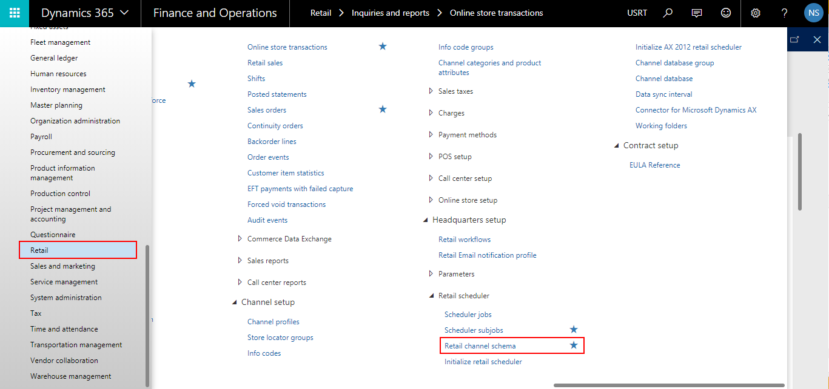

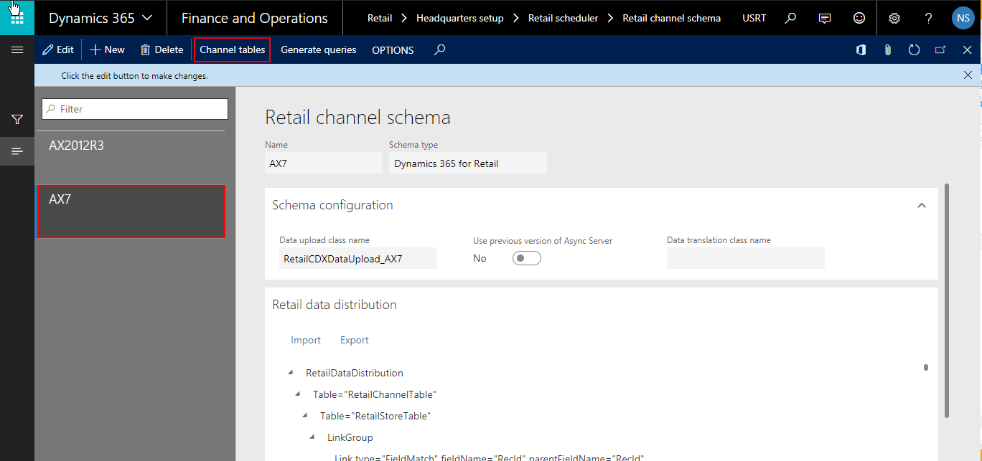

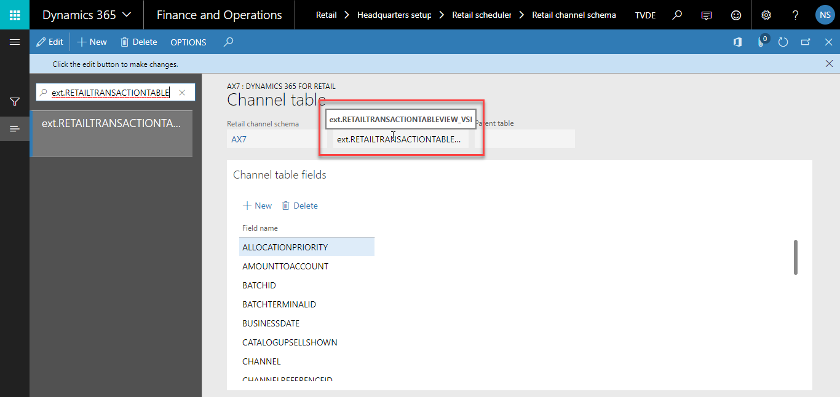

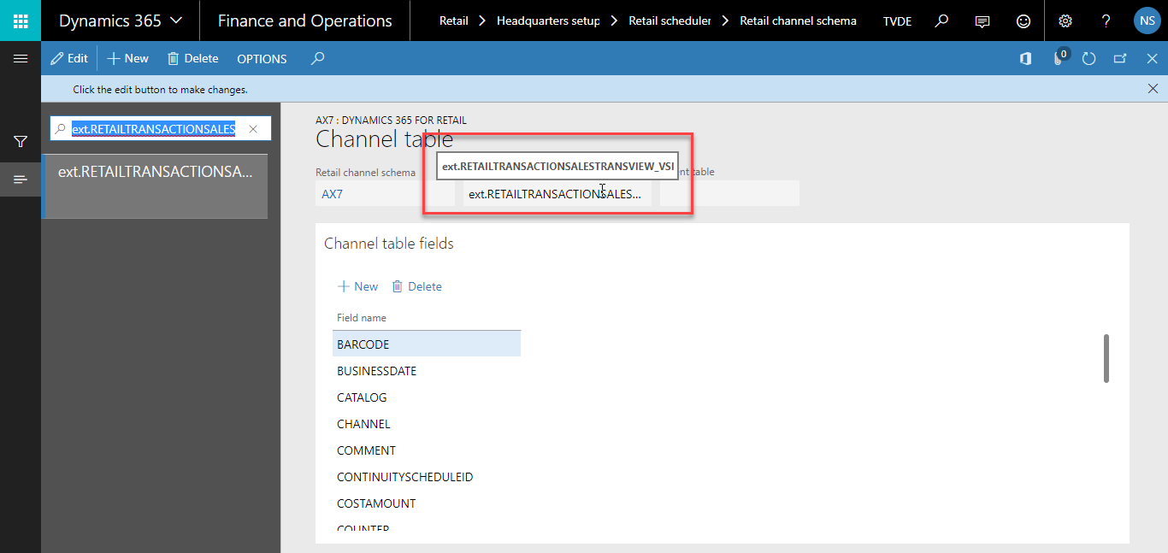

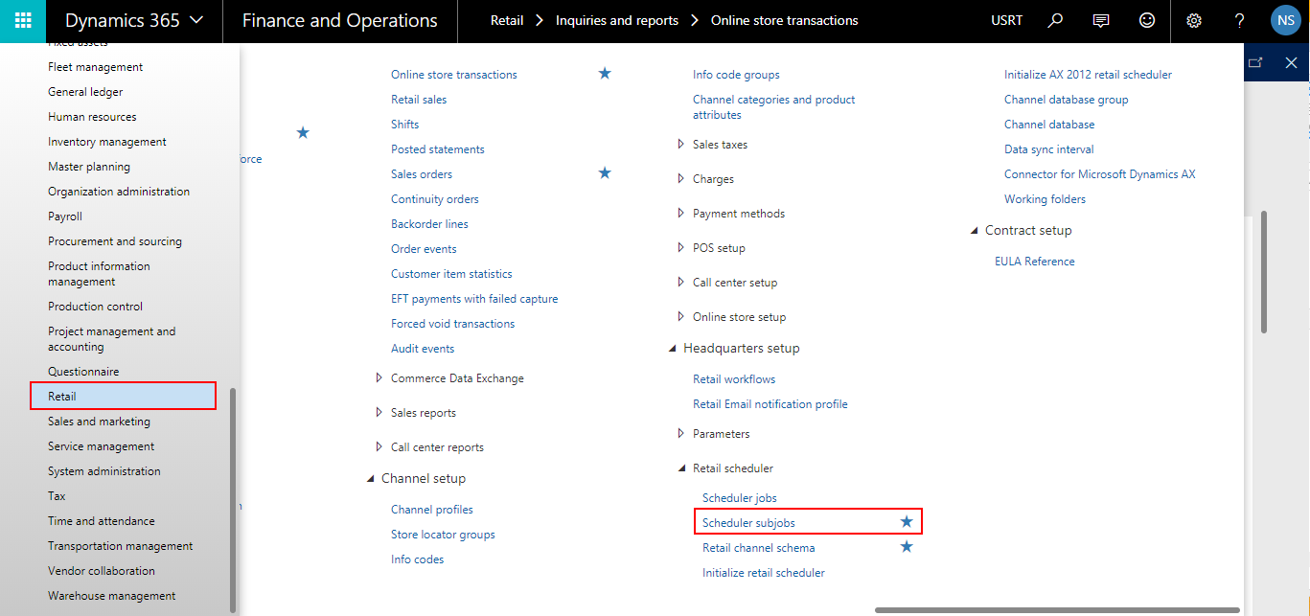

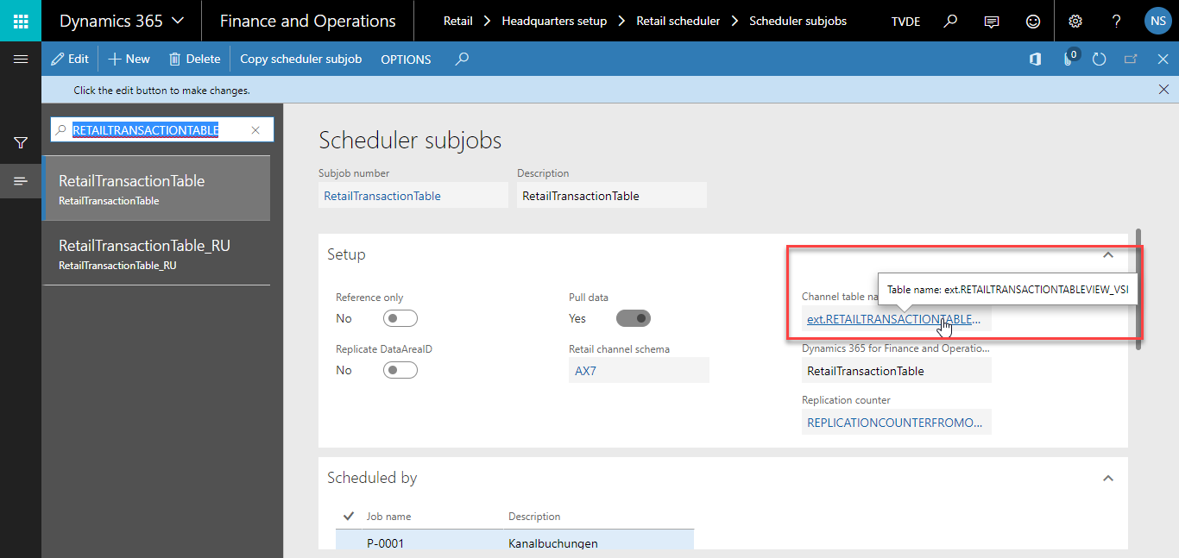

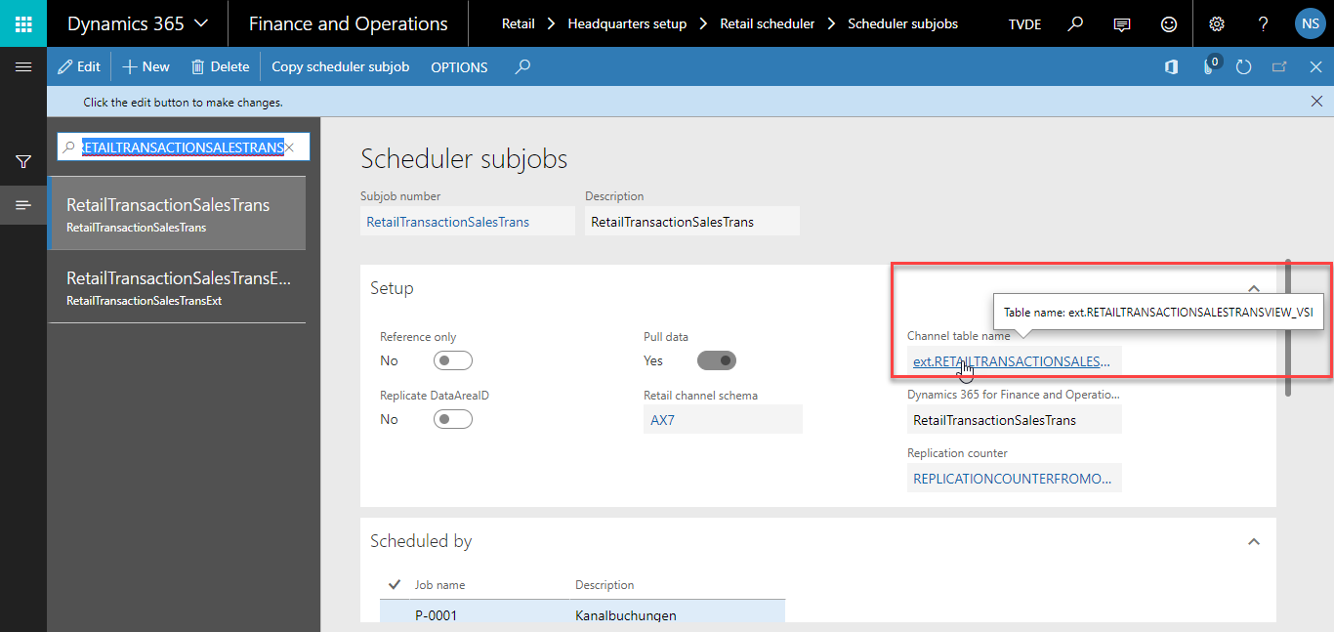

## 1.2. Channel Database Changes:

1. Verify following custom tables with all primary fields exist in channel database.

|  |  |
| --- | --- |
| Channel Table Name | Custom Fields List |
| ext.RETAILTRANSACTIONTABLEVIEW_VSI | **TRANSACTIONID**  **STORE**  **CHANNEL**  **TERMINAL**  TMVResellerAccount  TMVDistributorAccount  TMVIndirectCustomer  TMVMainOfferType  TMVProductFamily  TMVSalesOrderSubType  TMVInvoiceScheduleComplete  TMVContractStatusLine  TMVSMMCAMPAIGNID  TMVPURCHORDERFORMNUM  TMVPIT  TMVQUOTATIONID |
| ext.RETAILTRANSACTIONSALESTRANSVIEW_VSI | **TRANSACTIONID**  **STORE**  **CHANNEL**  **TERMINALID**  **LINENUM**  TMVContractStatusLine  TMVContractValidFrom  TMVContractCalculateFrom  TMVContractValidTo  TMVContractPossTermDate  TMVContractCancelDate  TMVContractPossCancelDate  TMVContractTermDate  TMVContractTermDateEffective  TMVAutoProlongation  TMVPurchOrderFormNum  TMVCustomerRef  TMVContractStatusLine  TMVEULAVersion  TMVBillingPeriod  PACLicense  TMVOriginalLineAmount  TMVLineModified  TMVReversedLine |

2. Verify custom view “ext.RETAILTRANSACTIONTABLEVIEW_VSI” exist in channel database

3. Verify custom view “ext.RETAILTRANSACTIONSALESTRANSVIEW_VSI” exist in channel database

5. Verify custom store procedure “ext.VSIUpdateSalesOrderExtension” exist in channel database

6. Verify custom store procedure “ext.VSIUpdateSalesLineExtension” exist in channel database

7. Verify execution permissions are grated on custom objects (User Defined Types & Store procedures) of channel database.

## 1.3. CommerceLink Database Changes:

N/A

## 1.4. CommerceLink Configurations:

Verify “**Read.ErpSalesOrder”** mapping template is updated in **“dbo.MappingTemplate”** table of CL database and “**Templates**” directory of CL instance.

## 1.5. Effected Areas:

CL WebAPI >> SalesOrder >> **CreateSalesOrderTransaction**

CL DataSyncService >> **SalesOrder** Job

## FDD-045 Service Profile Configuration

These tables are Change Tracking enabled, therefor we need to execute “Full Data Sync” for 1070 to sync old data.

## 2.1. D365 Configurations:

In AX we have Service Profile Screen:

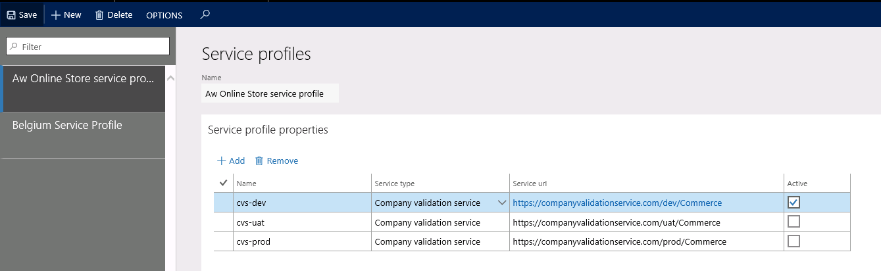

This profile has been assigned to related Online Store.

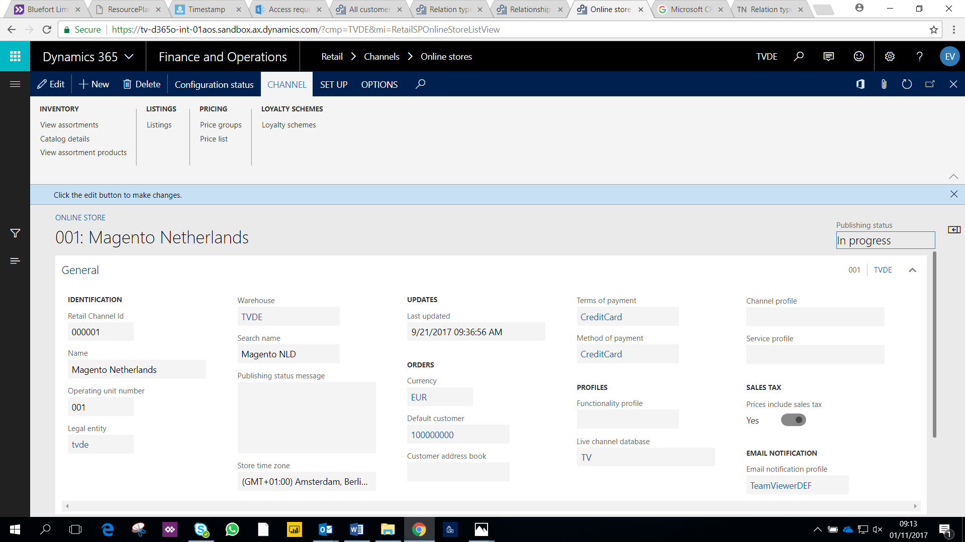

AOS Customization Mapping for following tables in Retail Channel Schema and add new custom field in channel tables.

1. ext.TMVRETAILSERVICEPROFILE_VSI
2. ext.TMVRETAILSERVICEPROFILEPROPERTY_VSI

### Adding Tables to Data Distribution

Add the new tables in the data distribution to the CRT for the retail channel

* Click Retail > Headquarters setup > Retail scheduler > Retail channel schema.
* Select the AX7 schema name (It may be changed with actual Schema name if required). Then click Channel tables.
* Click New, and then, in the Table name field, enter ext.TMVRETAILSERVICEPROFILE as the name of the new table.
* On the Channel table fields tab, click New, and then enter the field names:
  + CREATEDBY
  + CREATEDDATETIME
  + MODIFIEDBY
  + MODIFIEDDATETIME
  + NAME
  + PARTITION
  + RECID
  + RECVERSION
* Click New, and then, in the Table name field, enter ext.TMVRETAILSERVICEPROFILEPROPERTY as the name of the new table.
* On the Channel table fields tab, click New, and then enter the field names:
  + ACTIVE
  + CREATEDBY
  + CREATEDDATETIME
  + MODIFIEDBY
  + MODIFIEDDATETIME
  + NAME
  + PARTITION
  + RECID
  + RECVERSION
  + SERVICEPROFILE
  + SERVICETYPE
  + SERVICEURL
* Search ext.RETAILCHANNELTABLEEXT table.
* On the Channel table fields tab, click New, and then enter the field name:
  + TMVSERVICEPROFILE
* Close the Channel table’s page.

### Add Sub Jobs

Create a subjob

Create a subjob of the TMVRETAILSERVICEPROFILE_VSI job to move data in the new table to the channel database.

* In Retail Headquarters, click Retail > Headquarters setup > Retail scheduler > Scheduler subjobs, and then click New.
* In the Subjob number and Description fields, enter TMVRETAILSERVICEPROFILE.
* In the Retail channel schema field, select AX7 (Dynamics 365 for Retail).
* In the Channel table name field, select ext.TMVRETAILSERVICEPROFILE_VSI.
* In the table name field, select TMVRETAILSERVICEPROFILE_VSI.
* Save Changes
* In Channel Filed Mapping, Click Match Fields.
* Click Ok.
* Save Changes.

Create a subjob of the TMVRETAILSERVICEPROFILEPROPERTY_VSI job to move data in the new table to the channel database.

* In Retail Headquarters, click Retail > Headquarters setup > Retail scheduler > Scheduler subjobs, and then click New.
* In the Subjob number and Description fields, enter TMVRETAILSERVICEPROFILEPROPERTY.
* In the Retail channel schema field, select AX7 (Dynamics 365 for Retail).
* In the Channel table name field, select ext.TMVRETAILSERVICEPROFILEPROPERTY_VSI.
* In the table name field, select TMVRETAILSERVICEPROFILEPROPERTY_VSI.
* Save Changes
* In Channel Filed Mapping, Click Match Fields.
* Click Ok.
* Save Changes.

Edit a subjob of the RetailChannelTableExt job to move data in the new table Field to the channel database.

* In Retail Headquarters, click Retail > Headquarters setup > Retail scheduler > Scheduler subjobs, and then click New.
* Search RetailChannelTableExt Job.
* In Channel Filed Mapping, Click Match Fields.
* Click Ok.
* Save Changes.

### Generate Queries

* Now go to Retail->Headquarters setup->Retail scheduler->Retail channel schema
* Select AX7
* Now Run Generate Queries on Retail Channel Schema.

### Add Sub Jobs to 1070 Job

* Click Retail > Headquarters setup > Retail scheduler > Scheduler job.
* On the Scheduler job page, click 1070 to select the “Channel Configuration” job.
* On the Subjobs tab, click New, and then enter TMVRETAILSERVICEPROFILE_VSI as the subjob number. Click Save.
* On the Subjobs tab, click New, and then enter TMVRETAILSERVICEPROFILEPROPERTY_VSI as the subjob number. Click Save.

## 2.2. Channel Database Changes:

AX Database has following tables:

* ext.TMVRETAILSERVICEPROFILE
* ext.TMVRETAILSERVICEPROFILEPROPERTY
* ext.RETAILCHANNELTABLEEXT_VSI with new Column **TMVSERVICEPROFILE**

AX Database has following Stored Procedure:

* crt.VSIGetRetailServiceProfile
* crt.VSIGetRetailServiceProfilePropteries

Verify execution permissions are grated on custom objects (Store Procedures) of channel database.

## 2.3. CommerceLink Database Changes:

Following two Jobs have been added in CommerceLink Database:

|  |  |
| --- | --- |
| JobID | JobName |
| 124 | UploadConfigurationSync |
| 24 | ConfigurationSync |

## 2.4. CommerceLink Configurations:

Following Data File settings have been configured and available in UI:

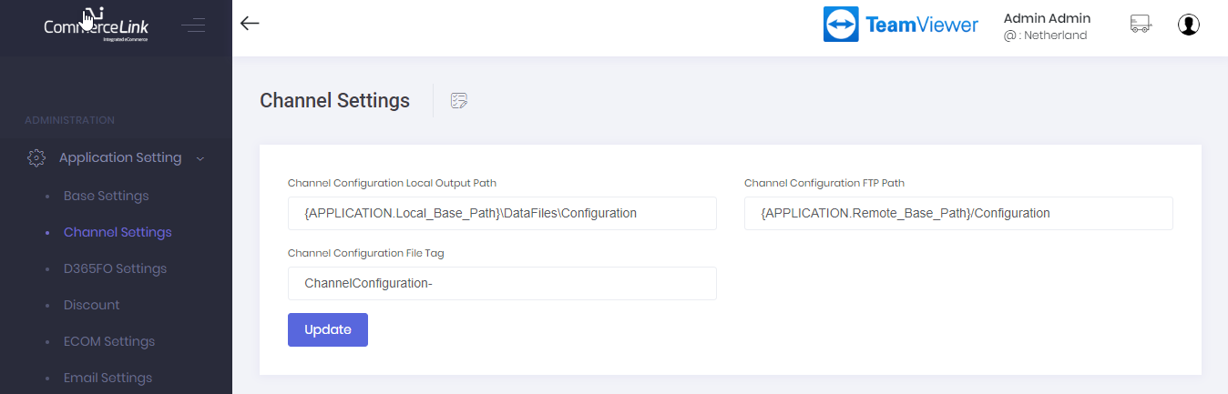

## 2.5. Effected Areas:

CL DataSyncService >> **Configuration** Job

## FDD-013 Channel Profile Configuration

## 3.1. D365 Configurations:

## Channel Profile Settings

If we have done customization for channel profile. So need to assign required channel profile on online channel from following screen.

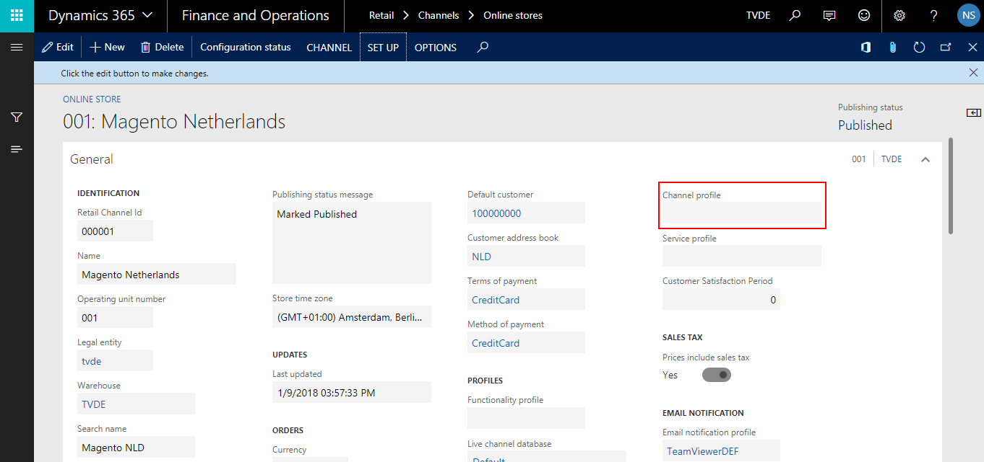

## Customer Satisfaction Period Settings

This is TMV customization to add customer satisfaction period on each channel from following screen.

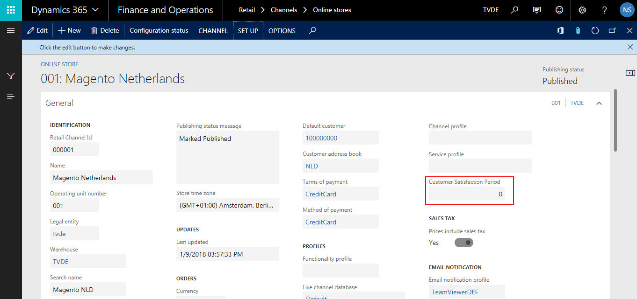

### Verify Table to Data Distribution

Verify columns in the data distribution to the CRT for the retail channel

* Click Retail > Headquarters setup > Retail scheduler > Retail channel schema.
* Select the AX7 schema name (It may be changed with actual Schema name if required). Then click Channel tables.
* Filter existing table **ext.RetailChannelTableExt_VSI**

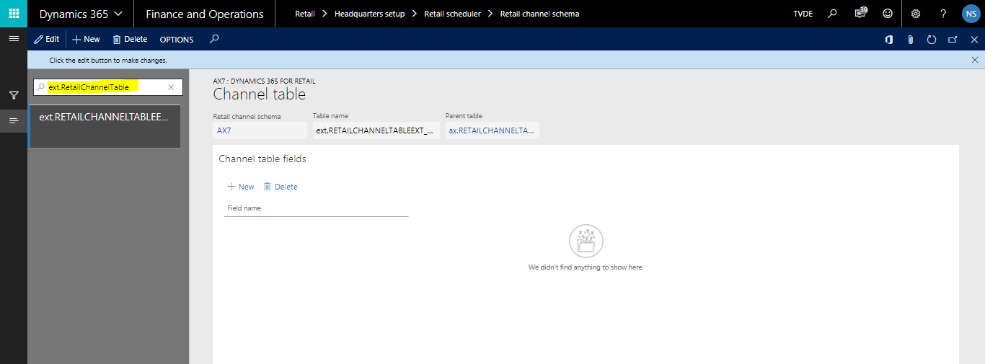

* Filter existing table **ax.RetailChannelTableExt**

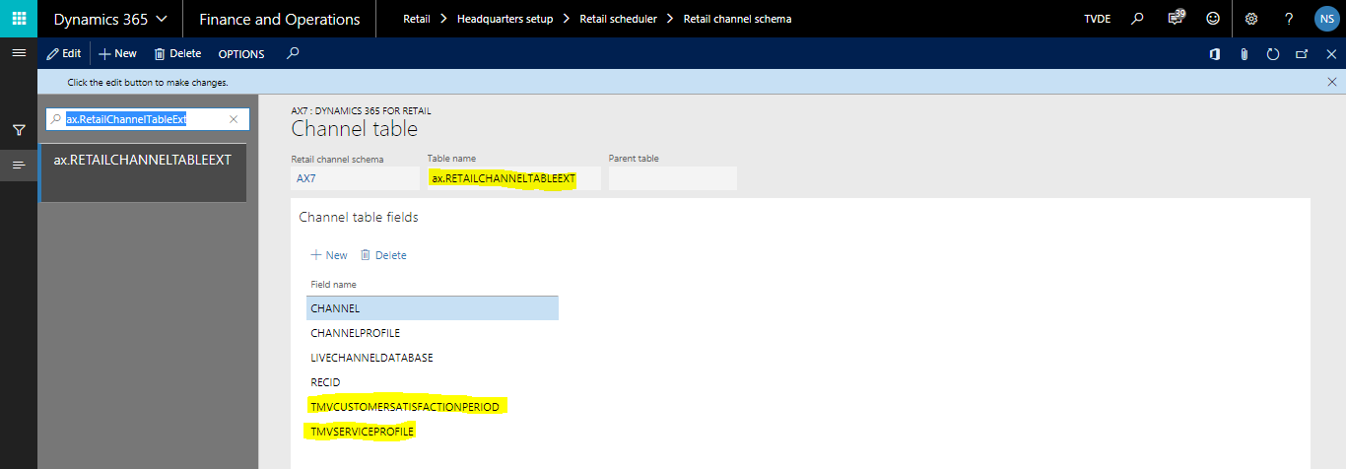

* On the Channel table verify required fields.
  + **TMVCustomerSatisfactionPeriod**

### Update Sub Jobs

Edit a subjob of the RetailChannelTableExt job to move data in the new table Field to the channel database.

* In Retail Headquarters, click Retail > Headquarters setup > Retail scheduler > Scheduler subjobs
* Search RetailChannelTableExt Job.

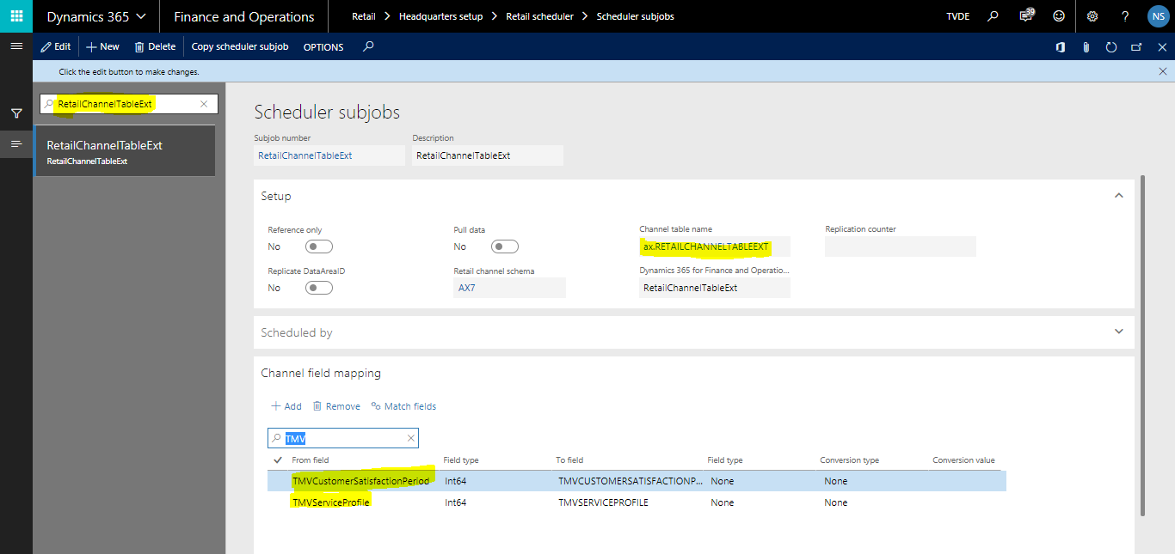

## 3.2. Channel Database Changes:

1. Verify following new table with custom fields exist and all primary keys in channel database.

|  |  |
| --- | --- |
| Channel Table Name | Custom Fields List |
| ext.RetailChannelTableExt_VSI | **RECID**  TMVCUSTOMERSATISFACTIONPERIOD  TMVSERVICEPROFILE |

2. Verify following custom view exist in channel database.

1. **ext.RETAILCHANNELTABLEEXTVIEW_VSI**

3. Verify following custom store procedures exist in channel database.

1. **ext.VSIGetChannelCustomProperties**
2. **ext.VSIGetRetailChannelProfile**
3. **ext.VSIGetRetailChannelProfilePropteries**

Verify execution permissions are grated on custom objects (Store Procedures) of channel database.

## 3.3. CommerceLink Database Changes:

This FDD is extension of FDD-045 Service Profile so its CL database changes have been done with that FDD.

## 3.4. CommerceLink Configurations:

1. Verify Channel Configuration jobs (DataSync and FileSync) are active with specified time interval.

2. Verify Channel Configuration data files paths are properly configured under **“CL UI >> Configuration >> Data Files”** section.

## 4.5. Effected Areas:

CL DataSyncService >> **ChannelConfiguration** Job

## FDD-001 and FDD-012 Product Information and Base Price

## 4.1. Cross sell/Up sell Changes:

## 4.1.1. D365 Configurations:

Cross Sell are configured on Released Products. It is important to note that Catalog must contain all product and cross-sell.

* Click Product information management > Products > Released products.
* Open product Detail.  
  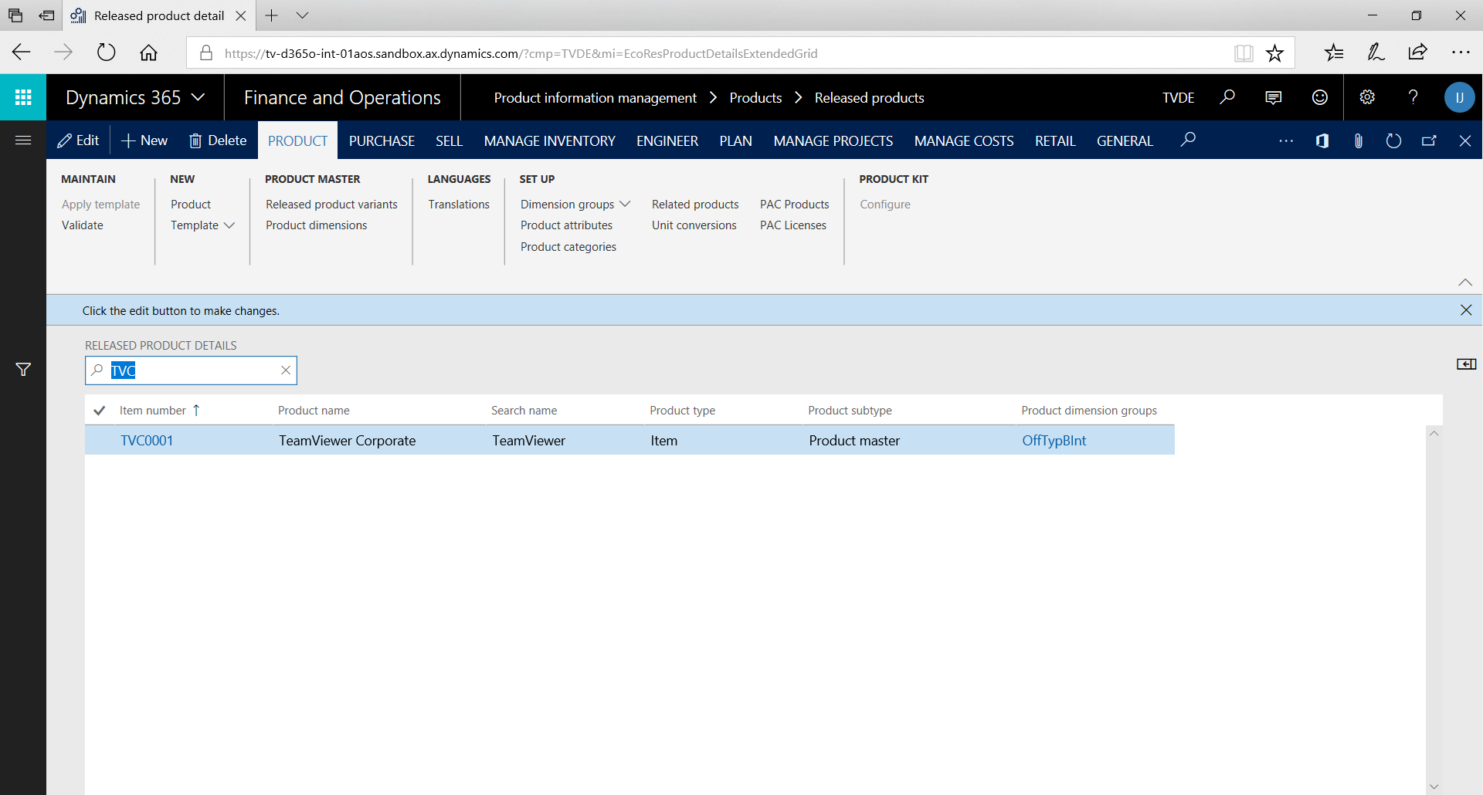
* Click Setup > Up-Sell/Cross-Sell Setup.  
  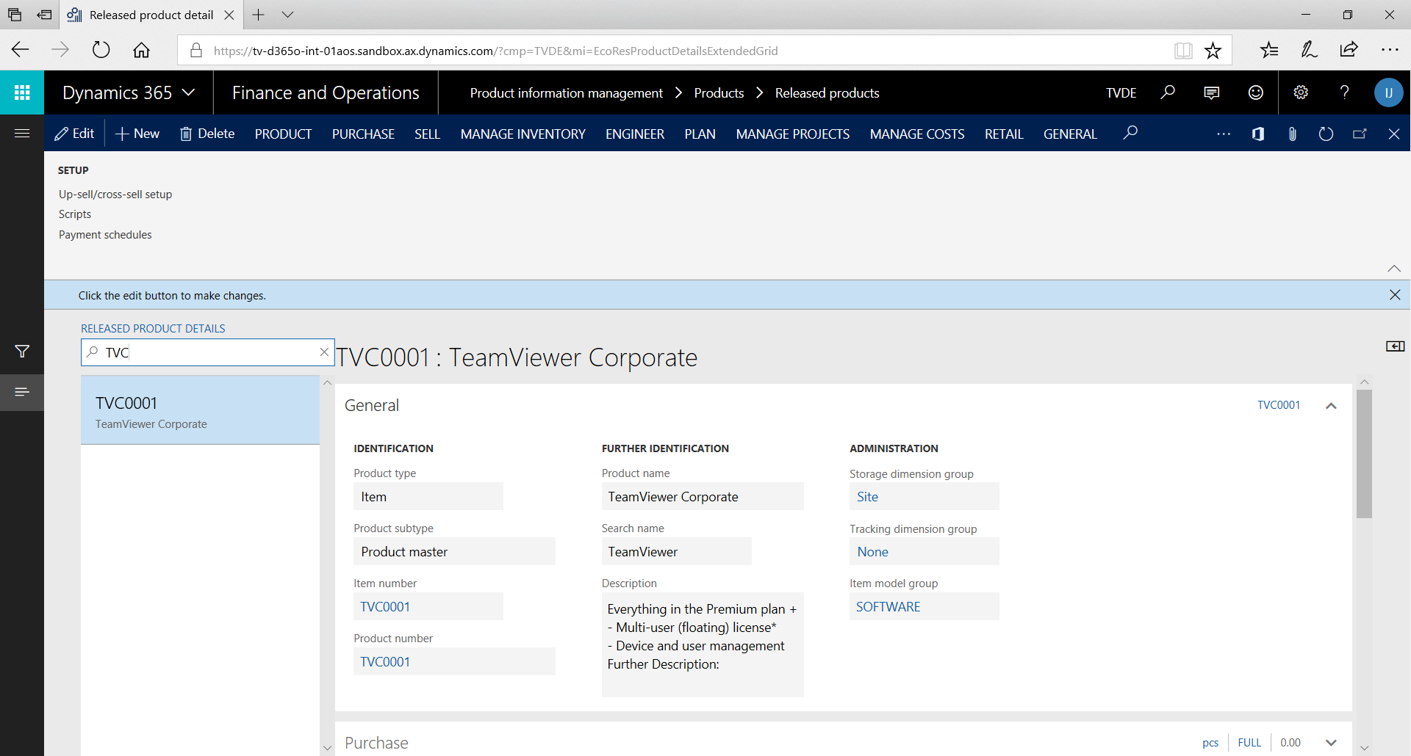
* Add Cross Sell with Add-on type.  
  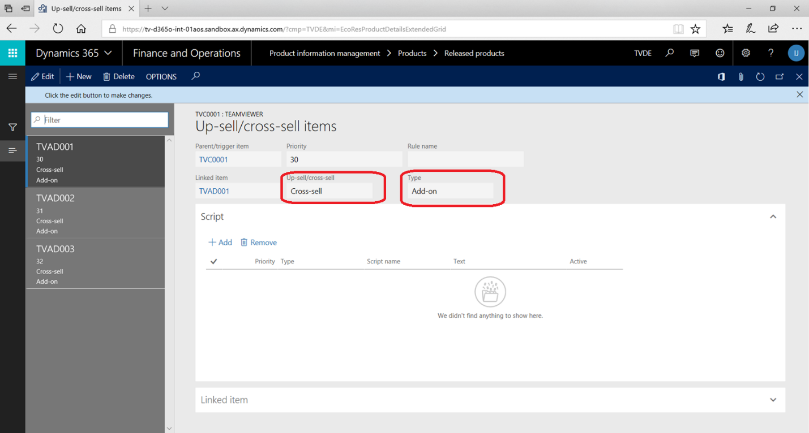

Required Upsell Items has been configured as per business requirements:

AOS Customization Mapping for following tables in Retail Channel Schema and add new custom field in channel tables.

1. ext. MCRUPSELLITEM

### Adding Tables to Data Distribution

Add the new tables in the data distribution to the CRT for the retail channel

* Click Retail > Headquarters setup > Retail scheduler > Retail channel schema.
* Select the AX7 schema name (It may be changed with actual Schema name if required). Then click Channel tables.
* Click New, and then, in the Table name field, enter ext.MCRUPSELLITEM as the name of the new table.
* On the Channel table fields tab, click New, and then enter the field names:
  + CATALOG
  + ITEMID
  + LINKEDITEM
  + PRIORITY
  + PRODUCT
  + RULEID
  + SCRIPT
  + UPSELLTYPE
  + RECVERSION
  + PARTITION
  + RECID
  + TMVCROSSSELLTYPE
  + TMVUPSELLTYPE
* Close the Channel table’s page.

### Add Sub Jobs

Create a subjob

Create a subjob of the MCRUPSELLITEM job to move data in the new table to the channel database.

* In Retail Headquarters, click Retail > Headquarters setup > Retail scheduler > Scheduler subjobs, and then click New(We don’t need to do this as this is already part of CDX)
* In the Subjob number and Description fields, enter MCRUPSELLITEM.
* In the Retail channel schema field, select AX7 (Dynamics 365 for Retail).
* In the Channel table name field, select ax.MCRUPSELLITEM.
* In the **Dynamics 365 for Finance and Operations table name** field, select MCRUPSELLITEM.
* Save Changes
* In Channel Filed Mapping, Click Match Fields.
* Click Ok.
* Save Changes.

### Generate Queries

* Now go to Retail->Headquarters setup->Retail scheduler->Retail channel schema
* Select AX7
* Now Run Generate Queries on Retail Channel Schema.

### Add Sub Jobs to 1150 Job

* Click Retail > Headquarters setup > Retail scheduler > Scheduler job.
* On the Scheduler job page, click 1150 to select the “Catalog Configuration” job.
* On the Subjobs tab, click New, and then enter MCRUPSELLITEM as the subjob number. Click Save.

## 4.1.2. Channel Database Changes:

AX Database has following tables:

* ext. MCRUPSELLITEM

AX Database has following Stored Procedure:

* crt.VSIGetUpsellItem

Verify execution permissions are grated on custom objects (Store Procedures) of channel database.

## 4.1.3. CommerceLink Database Changes:

Verify “**Create.ErpCatalog”** mapping template is updated in **“dbo.MappingTemplate”** table of CL database and “**Templates**” directory of CL instance. There are following newly added ApplicationSettings:

* PRODUCT.OfferTypeGroupName
* PRODUCT.CrossSellType

## 4.1.4. CommerceLink Configurations:

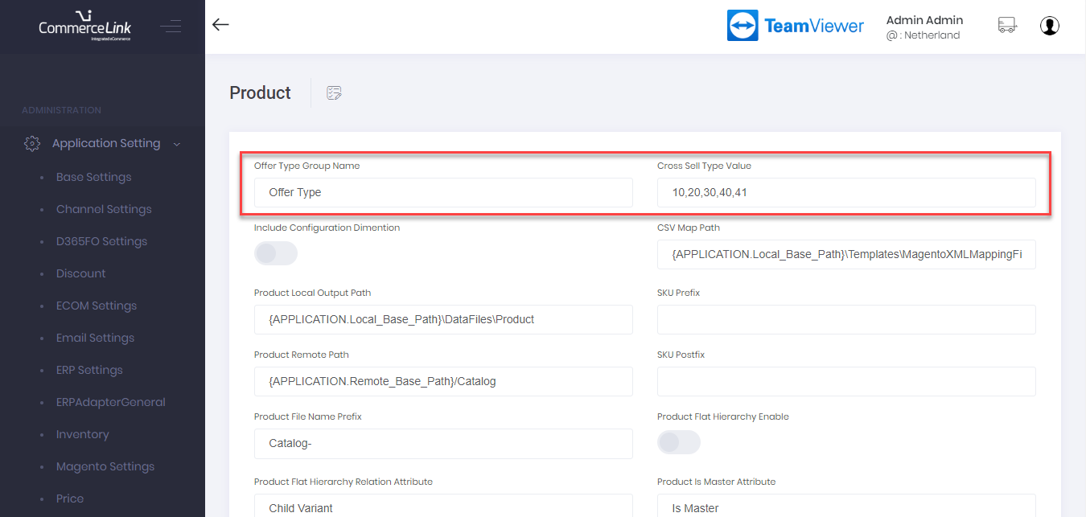

## 4.1.5. Effected Areas:

CL DataSyncService >> **ProductSyncJob** Job

## 4.2. Product Custom Fields:

## 4.2.1. D365 Configurations:

Required Upsell Items has been configured as per business requirements:

AOS Customization Mapping for following tables in Retail Channel Schema and add new custom field in channel tables.

* ext.RETAILSTYLEGROUPTRANS

### Adding Tables to Data Distribution

Add the new tables in the data distribution to the CRT for the retail channel

* Click Retail > Headquarters setup > Retail scheduler > Retail channel schema.
* Select the AX7 schema name (It may be changed with actual Schema name if required). Then click Channel tables.
* Click New, and then, in the Table name field, enter ext.RETAILSTYLEGROUPTRANS as the name of the new table.
* On the Channel table fields tab, click New, and then enter the field names:
  + NOINBARCODE
  + STYLE
  + STYLEGROUP
  + WEIGHT
  + RECVERSION
  + TMVMAINOFFERTYPE
  + TMVFREELICENSE
  + DISPLAYORDER
  + RECID
  + PARTITION

Close the Channel table’s page.

### Add Sub Jobs

Create a subjob

Create a subjob of the TMVRETAILSERVICEPROFILE job to move data in the new table to the channel database.

* In Retail Headquarters, click Retail > Headquarters setup > Retail scheduler > Scheduler subjobs, and then click New.
* In the Subjob number and Description fields, enter RETAILSTYLEGROUPTRANS.
* In the Retail channel schema field, select AX7 (Dynamics 365 for Retail).
* In the Channel table name field, select ext. RETAILSTYLEGROUPTRANS.
* In the table name field, select RETAILSTYLEGROUPTRANS.
* Save Changes
* In Channel Filed Mapping, Click Match Fields.
* Click Ok.
* Save Changes.

### Generate Queries

* Now go to Retail->Headquarters setup->Retail scheduler->Retail channel schema
* Select AX7
* Now Run Generate Queries on Retail Channel Schema.

### Add Sub Jobs to 1040 Job

* Click Retail > Headquarters setup > Retail scheduler > Scheduler job.
* On the Scheduler job page, click 1040 to select the “Products” job.
* On the Subjobs tab, click New, and then enter as the subjob number. Click Save.
* On the Retail channel schema page, select Dynamics 365 for Retail **as the schema name, and then click **Generate queries

## 4.2.2. Channel Database Changes:

AX Database has following tables:

* ext. MCRUPSELLITEM

AX Database has following Stored Procedure:

* crt.VSIGetProductCustomField

Verify execution permissions are grated on custom objects (Store Procedures) of channel database.

## 4.2.3. CommerceLink Database Changes:

Verify “**Create.ErpCatalog”** mapping template is updated in **“dbo.MappingTemplate”** table of CL database and “**Templates**” directory of CL instance.

## 4.2.4. CommerceLink Configurations:

N/A

## 4.2.5. Effected Areas:

CL DataSyncService >> **ProductSyncJob** Job

## FDD-006 Get Contract Order

## 5.1. D365 Configurations:

## 5.2. Channel Database Changes:

## 5.3. CommerceLink Database Changes:

## 5.4. CommerceLink Configurations:

## 5.5. Effected Areas:

## FDD-030 New Customer and New Contact Person After Signup

## 6.1. D365 Configurations:

N/A

## 6.2. Channel Database Changes:

N/A

## 6.3. CommerceLink Database Changes:

1. Verify Following keys exist in **“dbo.ApplicationSetting”** table of CL database.

* **SALESORDER.AX_Invoice_Address_Type**
* **SALESORDER.AX_Address_IsPrivate**

**2.** Verify “**Create.ErpCustomer**” mapping template is updated in **“dbo.MappingTemplate”** table of CL database and “**Templates**” directory of CL instance.

## 6.4. CommerceLink Configurations:

Set following values in CL UI under **Configuration >> ECom/ERP Settings**

* **AX Invoice Address Type = 9**
* **AX Address Is Private = False**

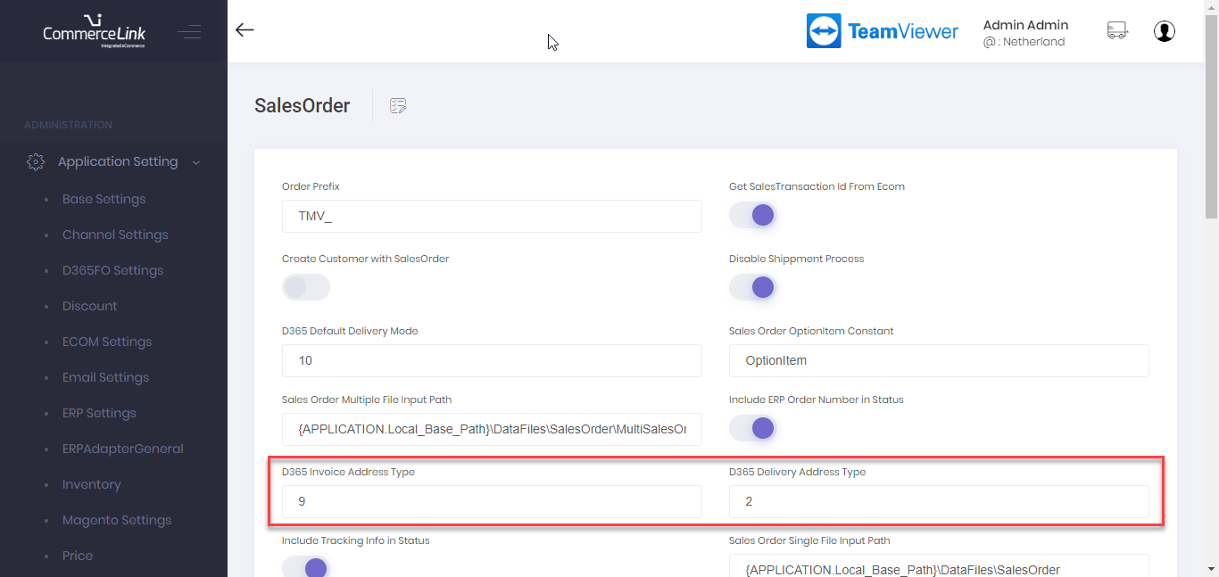

## 6.5. Effected Areas:

CL Web API >> Customer >> **CreateCustomer**

CL Web API >> Customer >> **CreateContactPerson**

## FDD-009 Interface Shopping Cart Handling, Pricing Engine and Coupons

## 7.1. D365 Configurations:

N/A

## 7.2. Channel Database Changes:

N/A

## 7.3. CommerceLink Database Changes:

N/A

## 7.4. CommerceLink Configurations:

N/A

## 7.5. Effected Areas:

CL Web API >> Cart >> **GetCart**

CL Web API >> Cart >> **CreateOrUpdateCart**

CL Web API >> Cart >> **AddCartLines**

CL Web API >> Cart >> **UpdateCartLines**

CL Web API >> Cart >> **RemoveCartLines**

CL Web API >> Cart >> **AddCouponsToCart**

CL Web API >> Cart >> **RemoveCouponsFromCart**

CL Web API >> Cart >> **UpdateDeliverySpecification**

## Multilingual

## 8.1. D365 Configurations:

## Multilingual Customization Mapping in AX

Add desired languages on online channel in AX.

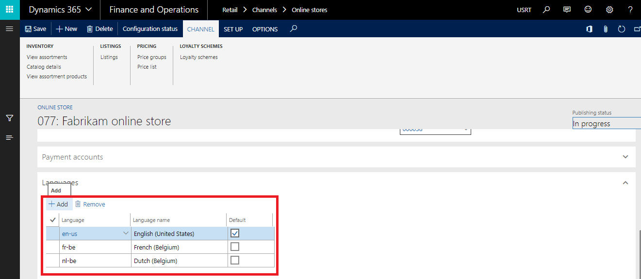

Run the Channel Configuration Job 1070.

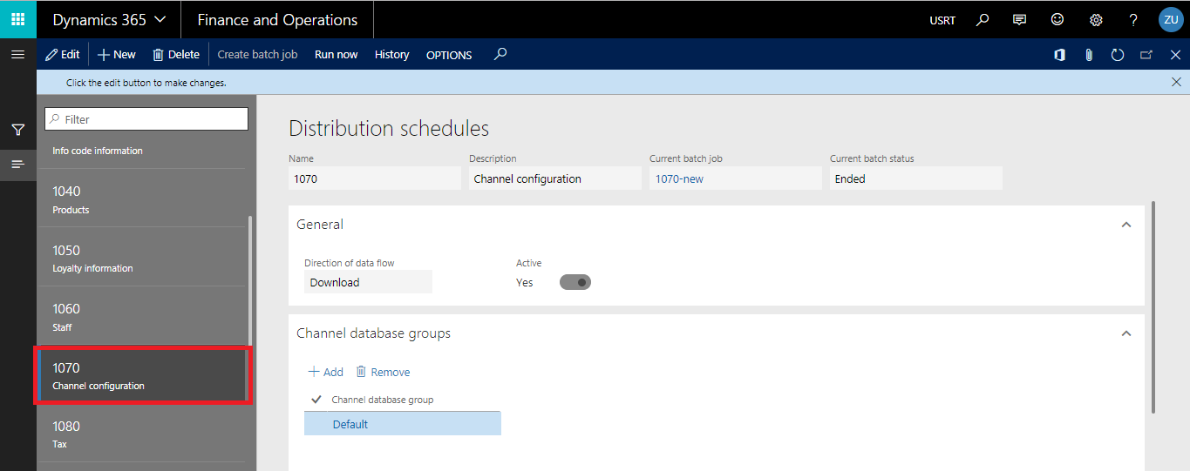

Publish the channel. (If Channel Publishing CL Job is running it will be done automatically on the set interval)

Open and Edit the catalog.

Select the product in catalog and click on attributes.

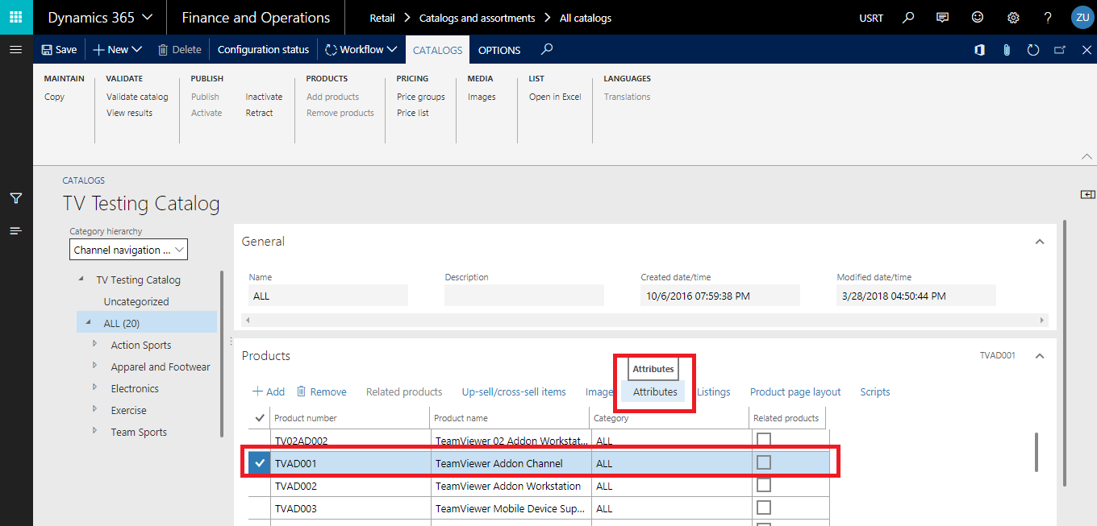

In the resultant screen click on Translate.

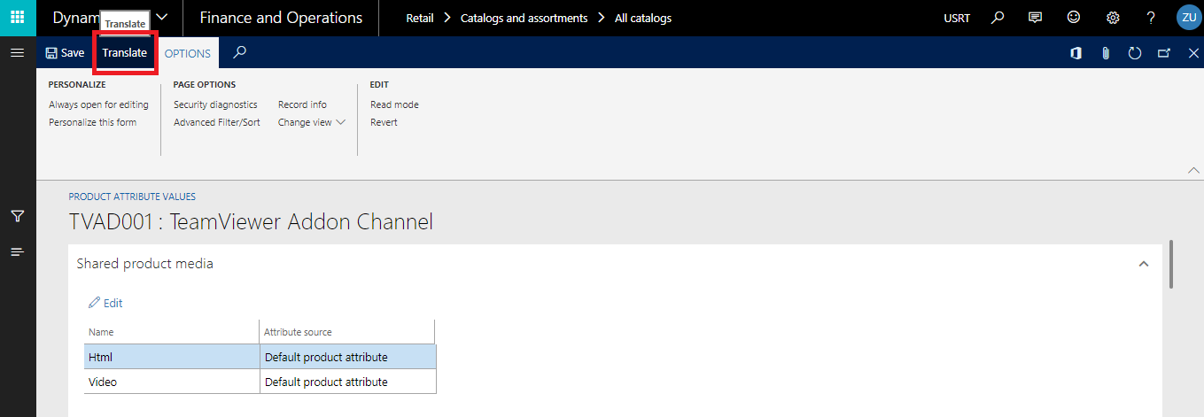

In the resultant screen if the language against which you want to add the translation does not already exist then click on Edit and then add the language in which you want to add translation.

If language is already added then choose that language and add the translation for “**Ecom Product Name**” custom attribute.

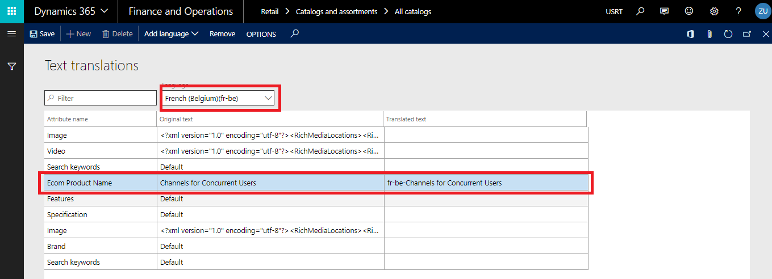

If this custom attribute is not present then first add it.

Add translations with the same procedure for the languages you desire and click on Save.

Repeat the same procedure for all the products in the catalog.

Save the Catalog.

In the Released Products under PIMS module search the product and then click on Translations.

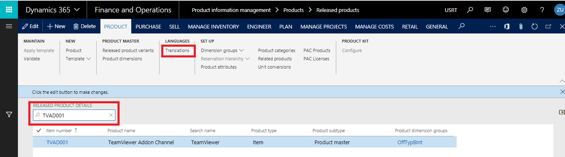In the resultant screen click on Edit and choose the language against which you want to add the translation for Description of Product.

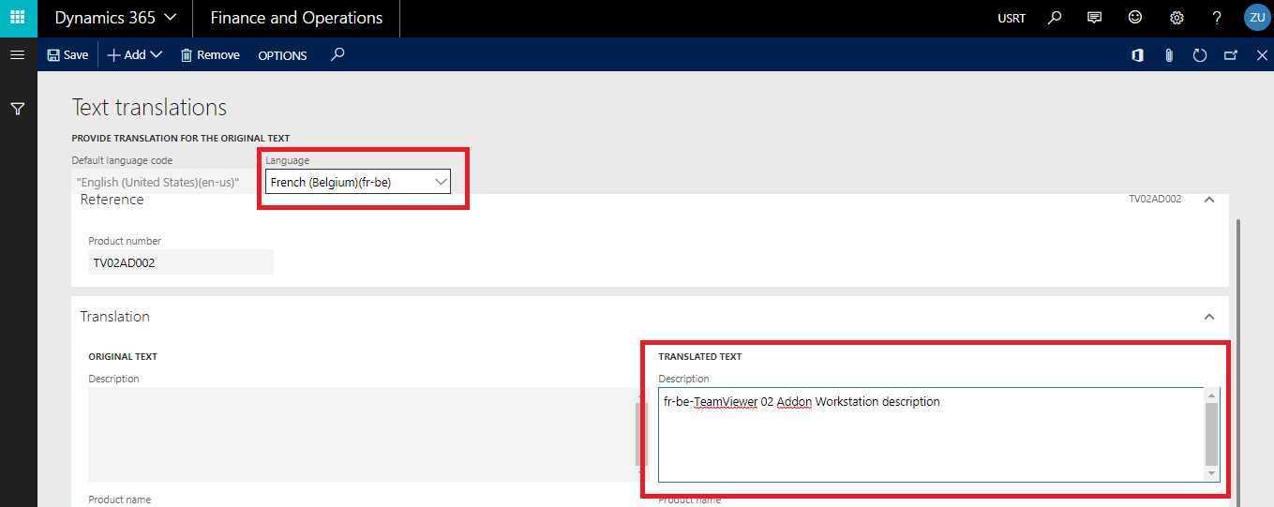

Add the translations for as many languages as desired.

Click on Save.

Repeat the same for all products in the Catalog.

Run the Products Job 1040.

Validate the catalog.

Submit the catalog for approval.

Once the catalog is approved publish the catalog by selecting **All Products** under the Publish drop down.

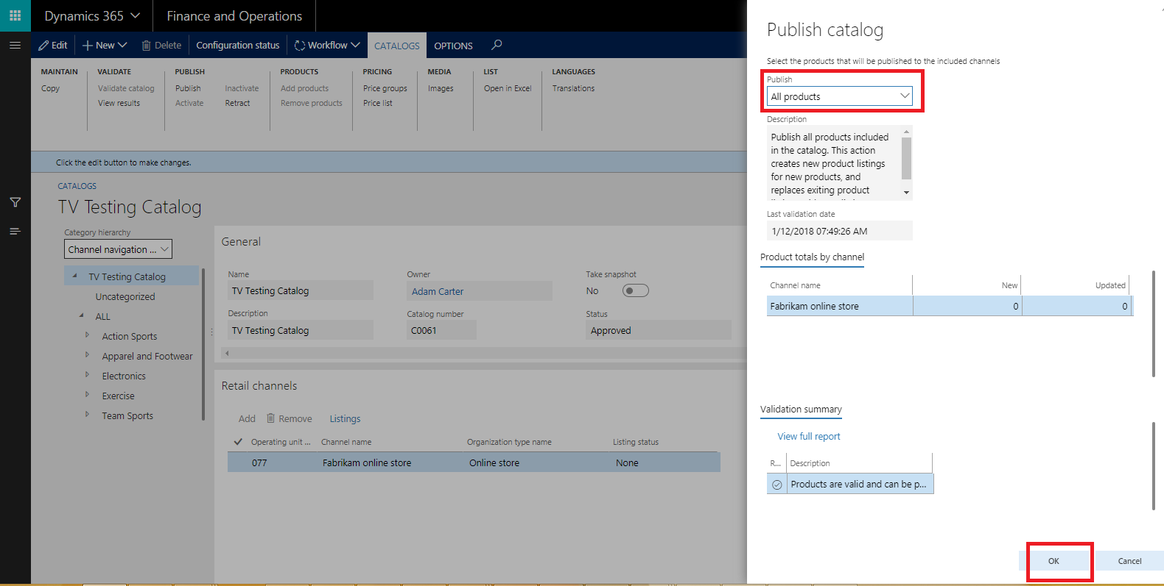

Run the Catalog Job.

## 8.2. Channel Database Changes:

N/A

## 8.3. CommerceLink Database Changes:

Verify “**CREATE.ErpCatalog.xml”** mapping template is updated in **“dbo.MappingTemplate”** table of CL database and “**Templates**” directory of CL instance.

Verify that the language code mapping between ERP (AX) and ECOM against languages added on online Channel in AX is present in **“dbo.ConfigurableObjects”** table.

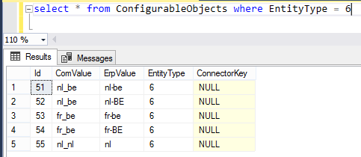

## 8.4. CommerceLink Configurations:

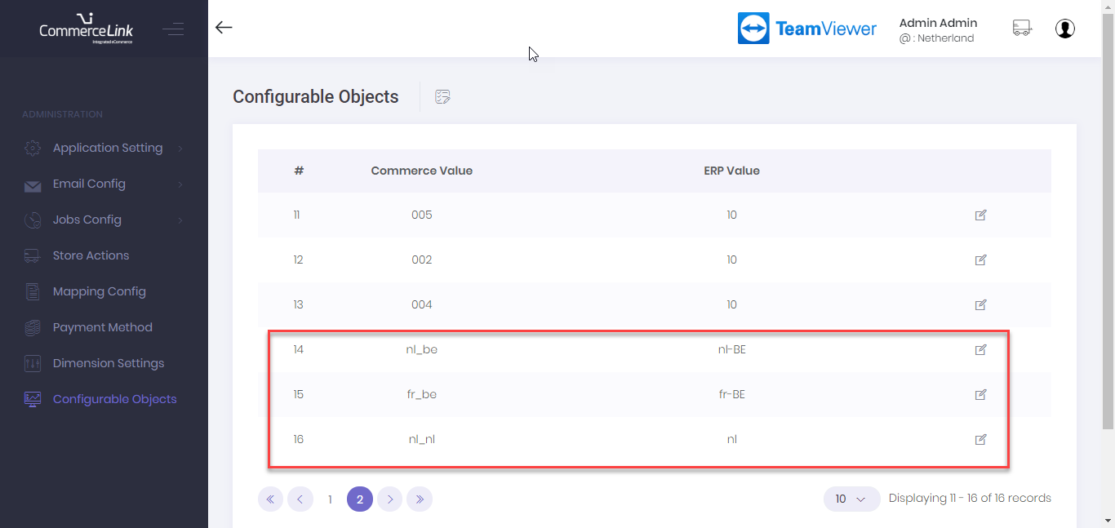

## 8.5. Effected Areas:

CL DataSyncService >> **Catalog** Job

## Sales Order Customizations

## 9.1. D365 Configurations:

N/A

## 9.2. Channel Database Changes:

N/A

## 9.3. CommerceLink Database Changes:

1. Verify Following keys exist in **“dbo.ApplicationSetting”** table of CL database.

* **SALESORDER.Get_SalesTransaction_Id_From_Ecom = True**
* **SALESORDER.Create_Customer_With_SalesOrder = False**
* **SALESORDER.Disable_Shippment_Process = True**
* **SALESORDER.AX_Default_Delivery_Mode = 10 (Download)**

2**.** Verify “**Read.ErpSalesOrder**” mapping template is updated in **“dbo.MappingTemplate”** table of CL database and “**Templates**” directory of CL instance.

3. Verify values of following keys are updated/configured in **“dbo.ApplicationSetting”** table of CL database.

* **SALESORDER.AX_Default_UnitofMeasure = PCS**
* **APPLICATION.ERP_AX_InferPeriodicDiscount = False**
* **INVENTORY.LocationId= “DC-CENTRAL” for Dev02 / “TVDE” for INT**

4**.** Verify values of following keys are updated/configured in **“dbo.ConfigurableObjects”** table of CL database.

* **SalesTaxGroup = NULL**
* **ItemTaxGroup= NULL**

## 9.4. CommerceLink Configurations:

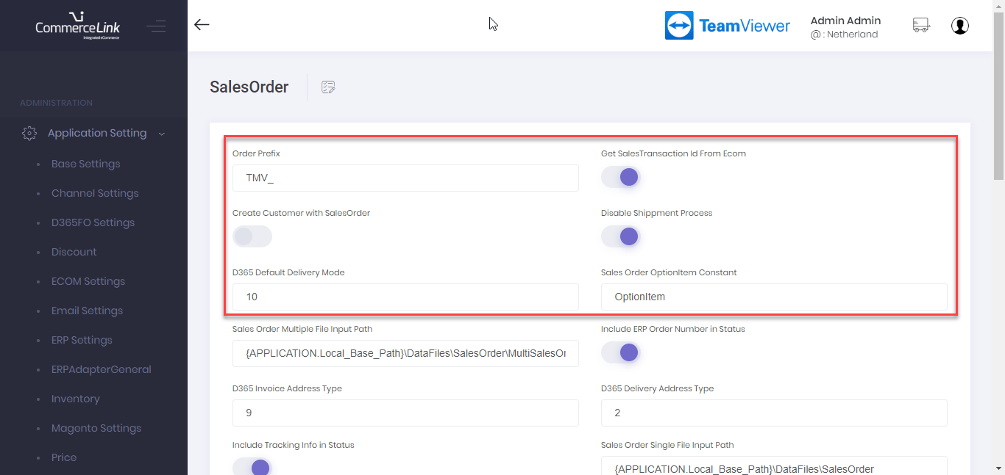

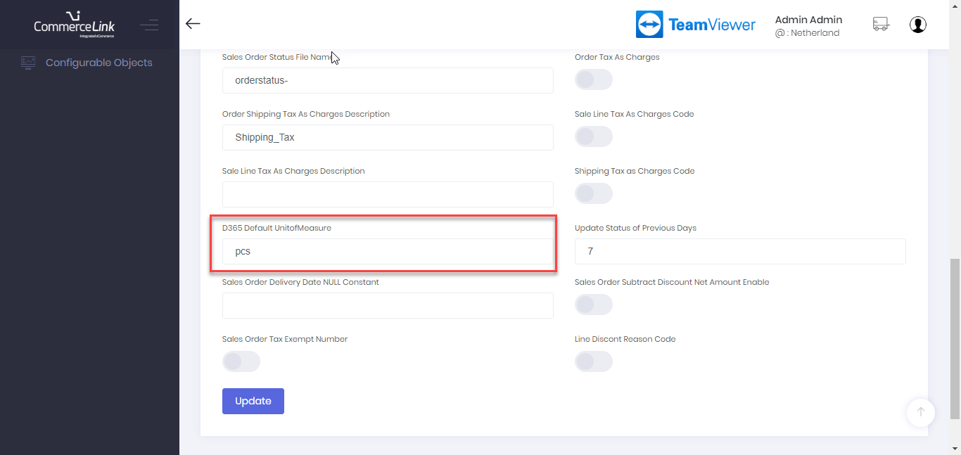

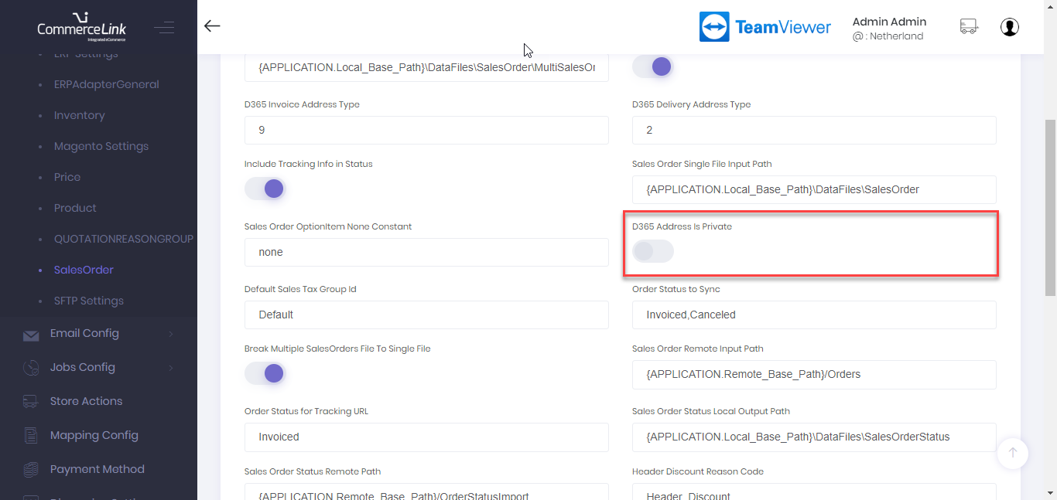

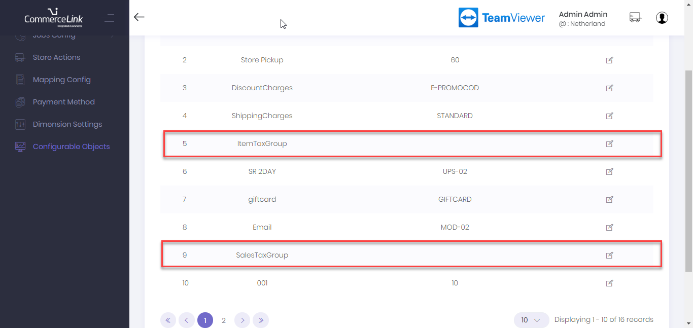

## 9.5. Effected Areas:

CL Web API >> **CreateSalesOrderTransaction**

## FDD-86 Payment connector

## 5.1. D365 Configurations:

TV requires 3 type of payment mode to be handled in Release 1. These are as under,

1. Simple (Customer invoice)
2. WireCard payment
3. PayPal Payments

Below are configurations steps that are that are required to work with ComemrceLink.

### Simple (Customer Invoice)

Navigate to online channel and select **Payment methods** as shown.

1. Add **Customer Account payment** method type

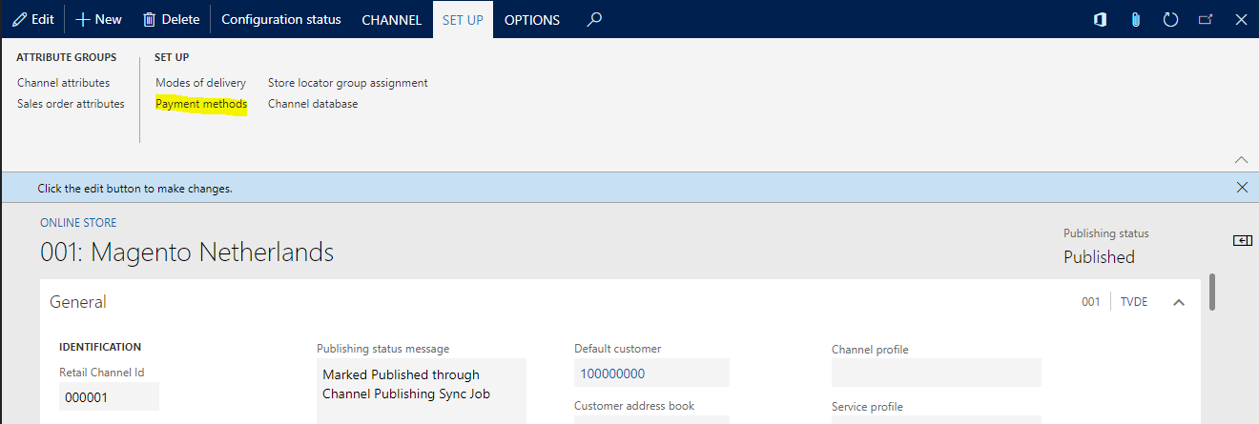

Add **customer account** type payment method.

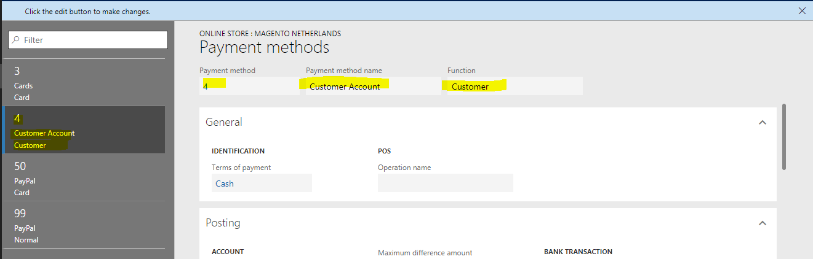

1. Add PayPal (card) payment method type.

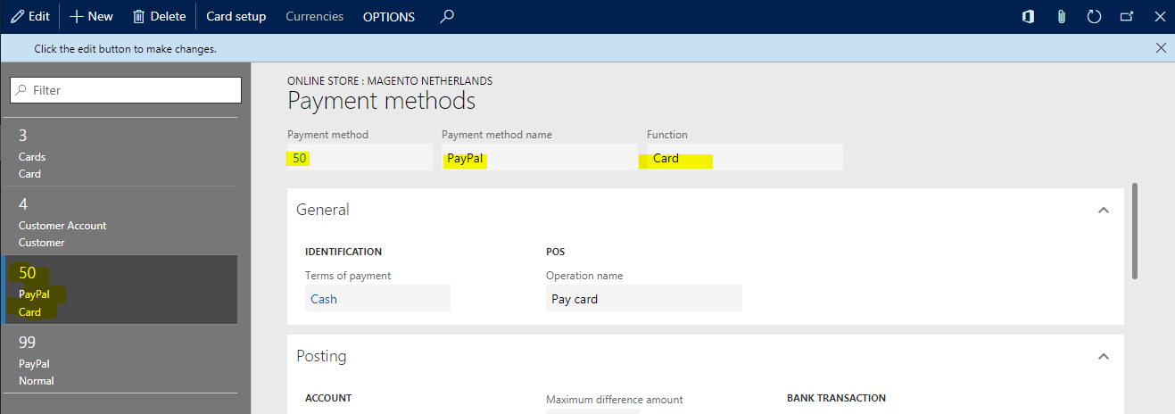

Click on **card setup**.

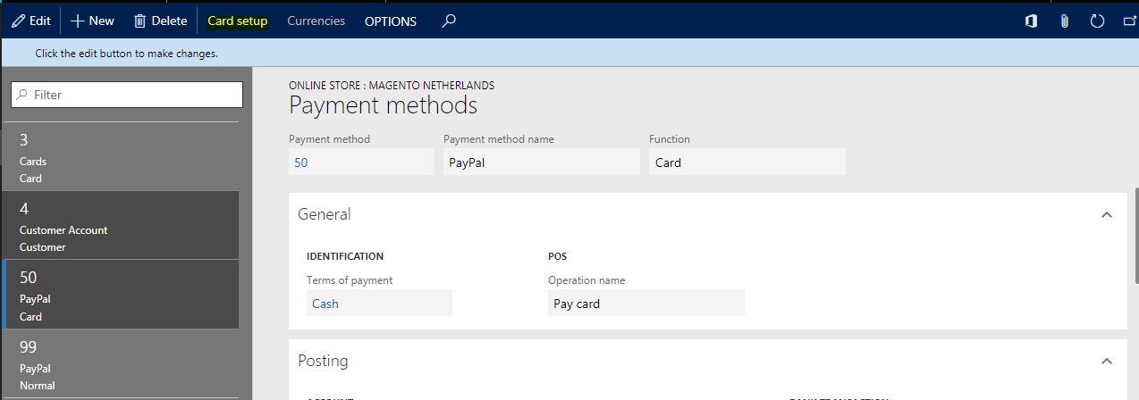

Setup card setting

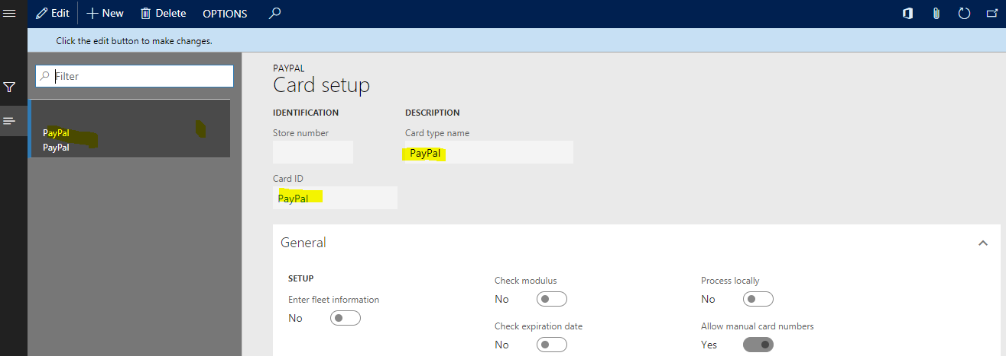

### WireCard Payment Connector

WireCard Payment connector need to attached on channel as well, however theses payment connector should already be exist in payment services module.

Navigate to the online channel to add payment connector in payment accounts section, using following steps.

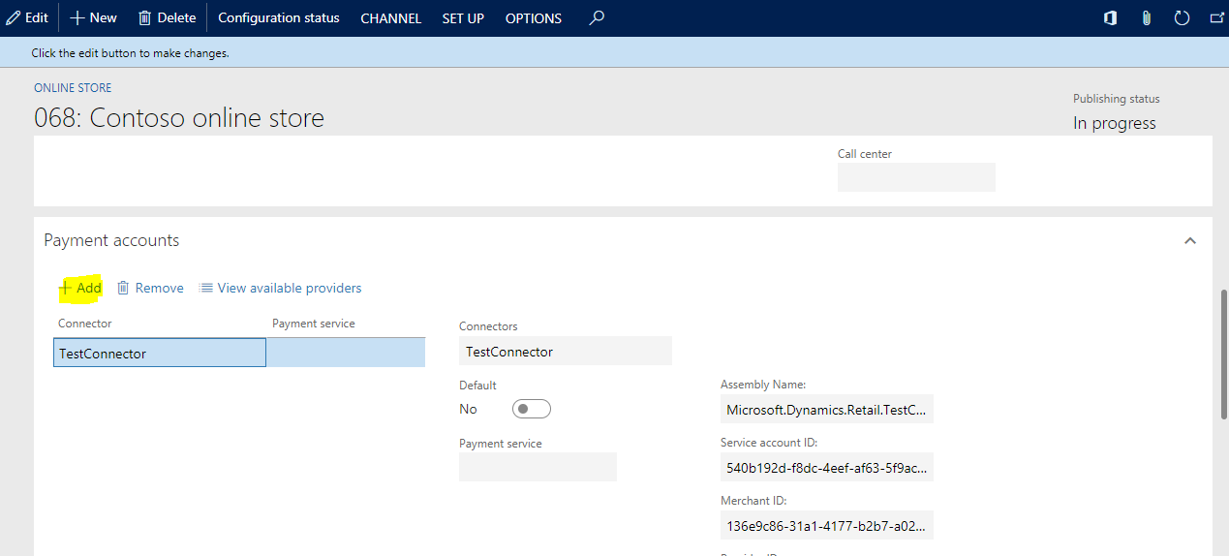

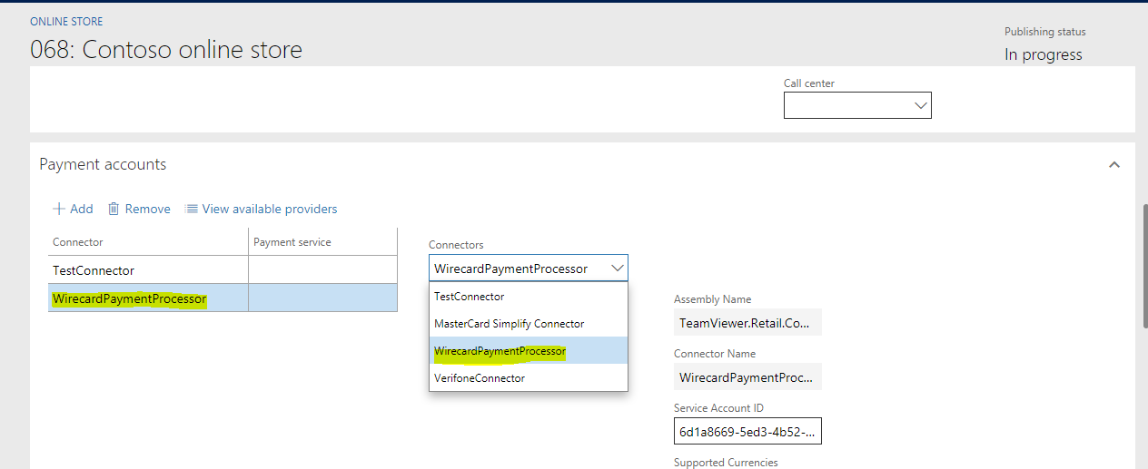

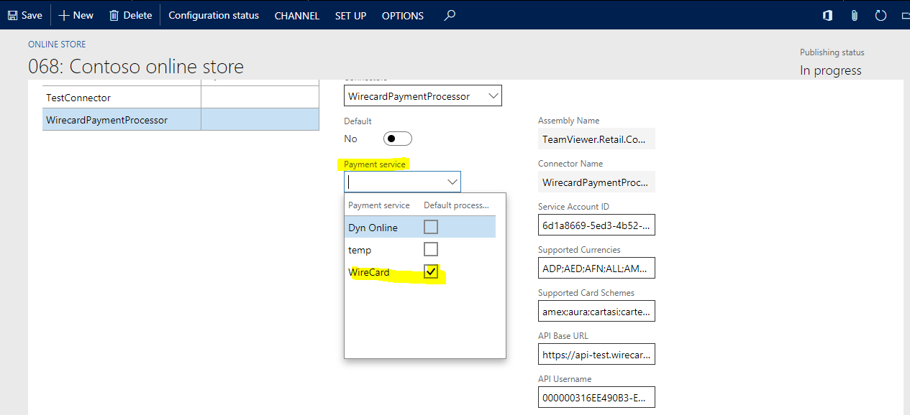

### PayPal Payment Connector

Paypal payment connector also need to be attached in payment accounts to fulfill payments via payment connector.

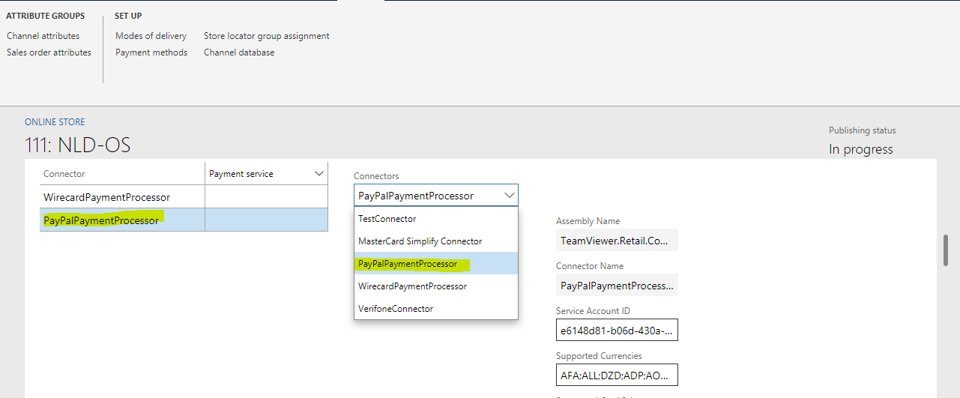

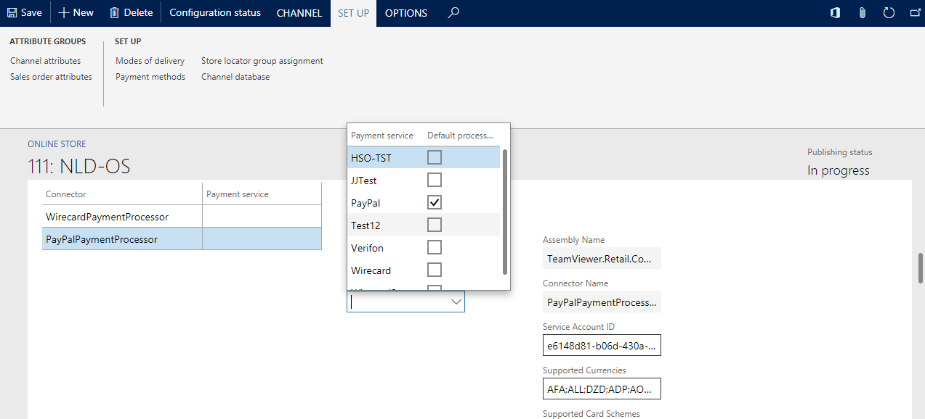

Run 1070 channel configuration job after all above configurations.

## 5.2. Channel Database Changes:

NA

## 5.3. CommerceLink Database Changes:

3 new columns are added in **PaymentMethod** table for payment connector configurations.

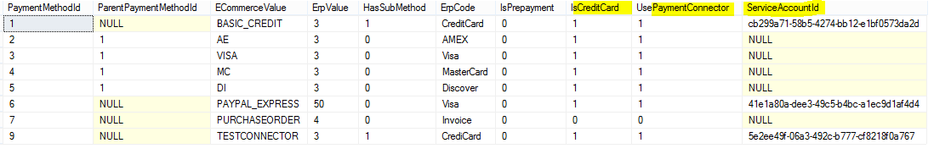

Update ErpSalesOrder template in **MappingTemplate** table, script is placed at directory.

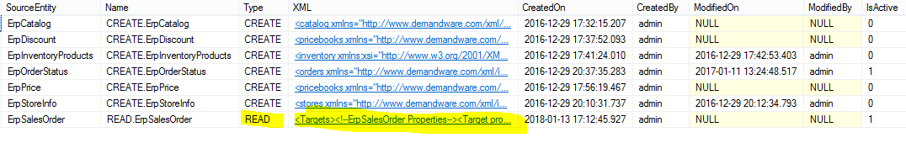

## 5.4. CommerceLink Configurations:

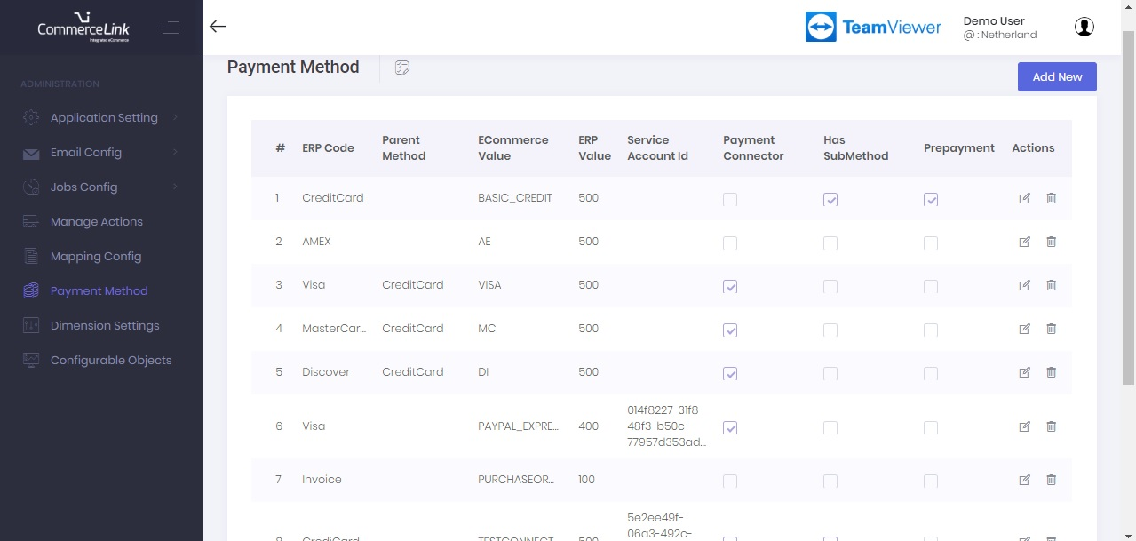

## 5.5. Effected Areas:

All Payments methods are added required for R1, including Customer account, WireCard and PayPal.

CL Web API >> **CreateSalesOrderTransaction**